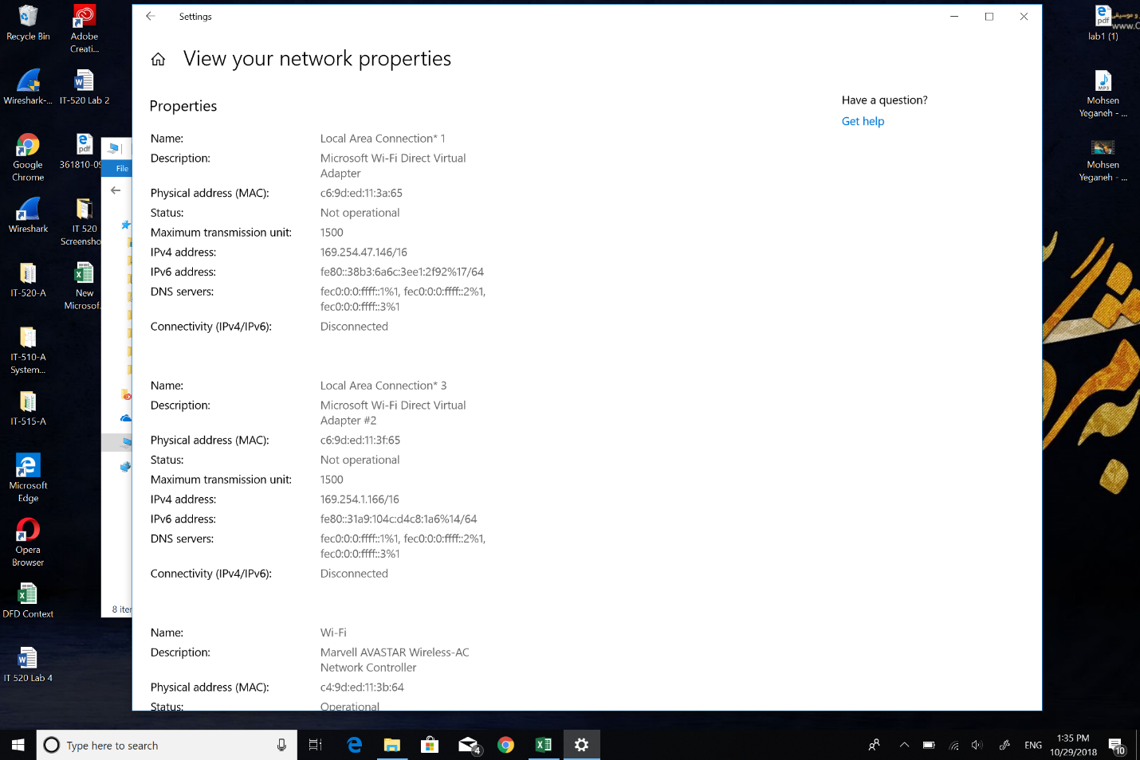1: The MAC address from my computer.



2: The destination MAC address is bellow.

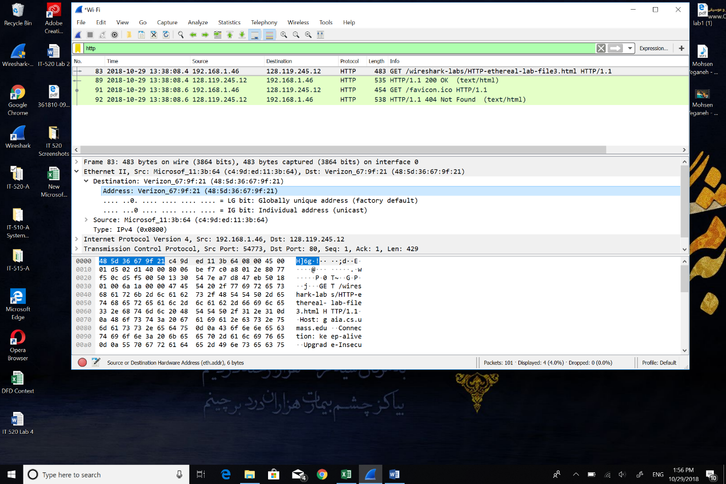



3: The destination device that shows in destination is a Verizon server.

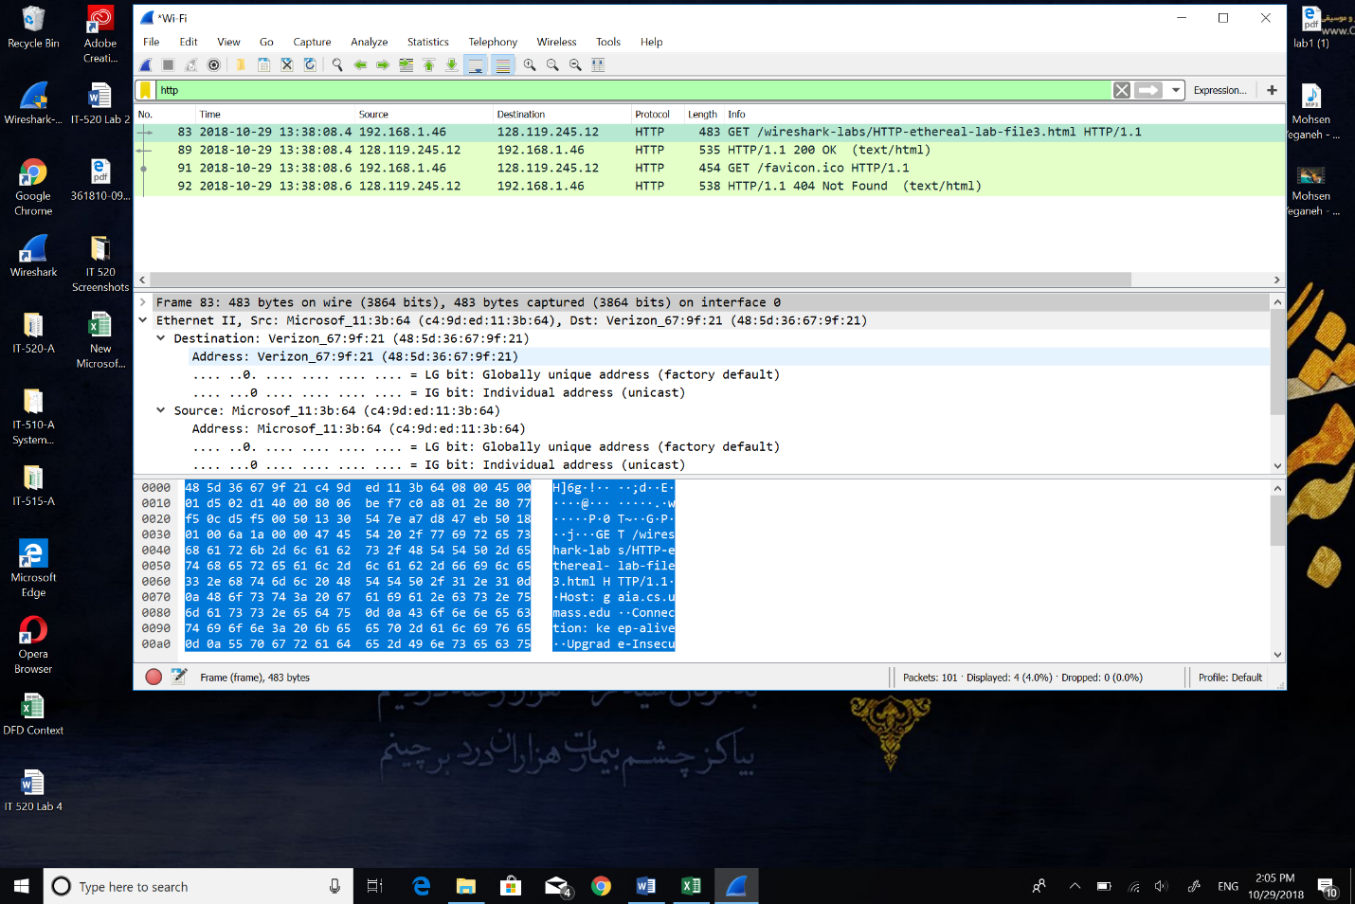



4: The IP address is an address bound to the network device, for example a computer or a server that is connected via software but the MAC address is a hardware address, which means it is unique to the network card installed on your PC. No two devices on a local network should ever have the same MAC address. Destination IP address is 128.119.245.12 and MAC address is 67:9f:21 (48:5d: 36: 67: 9f: 21).

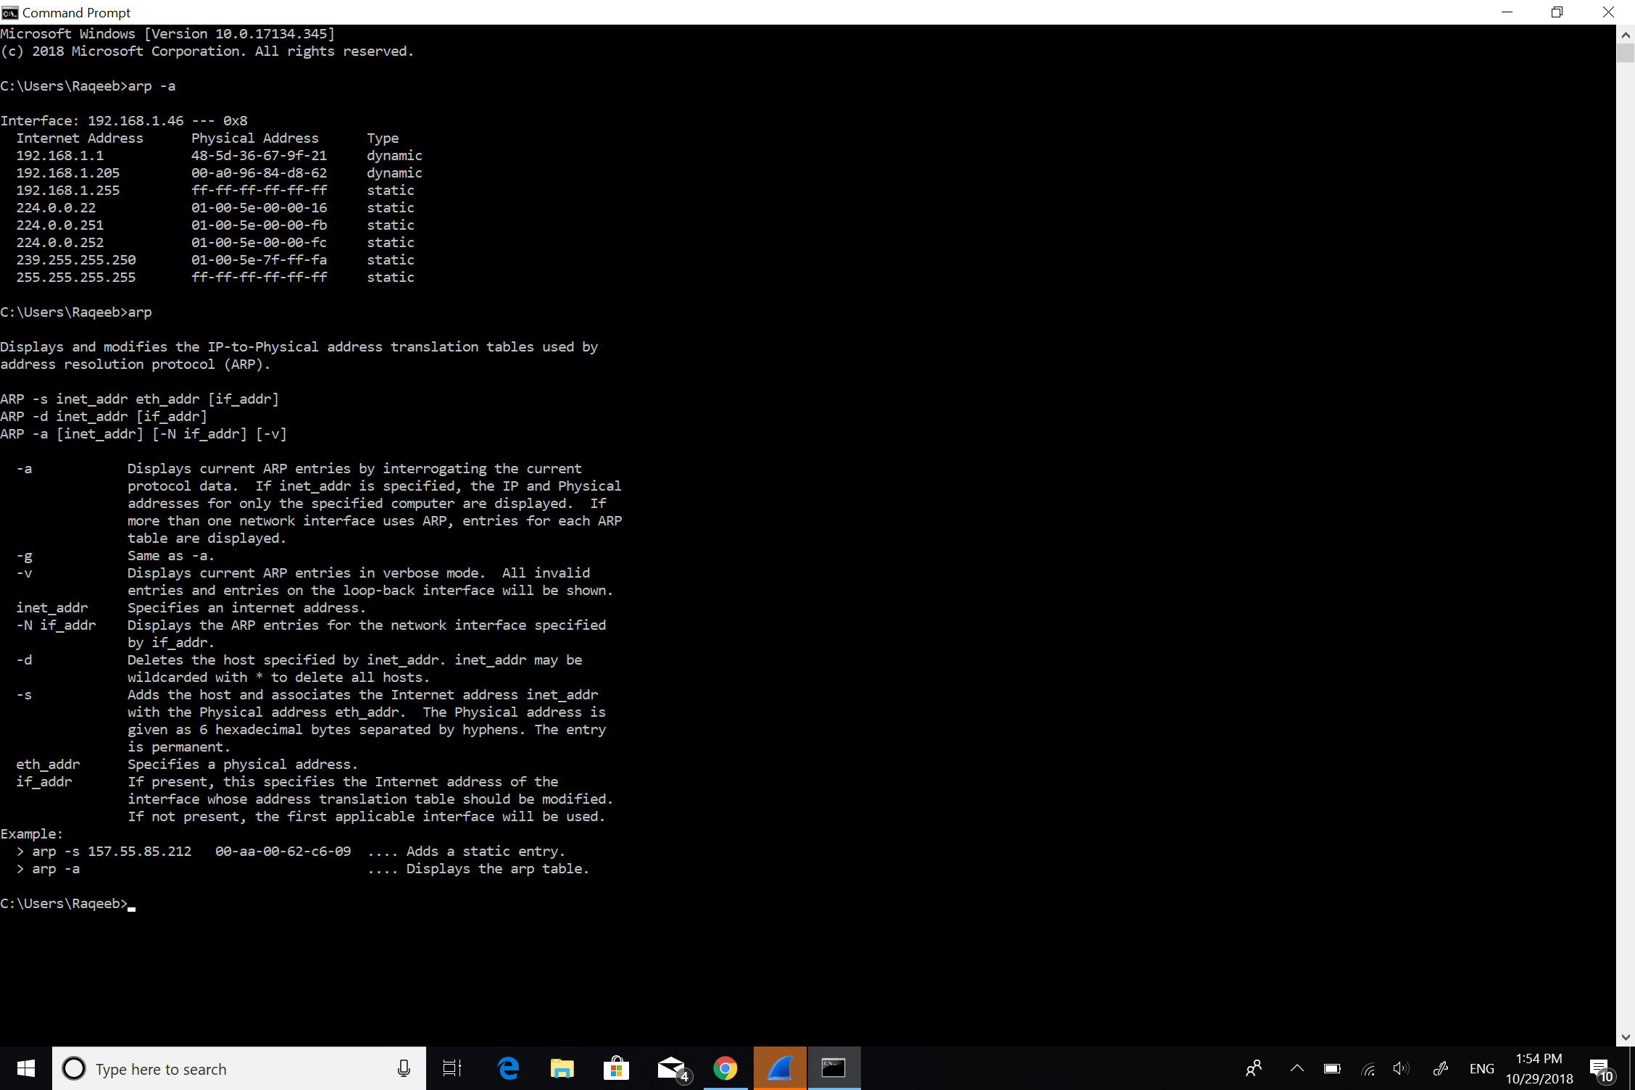5 The command for ARP list table is (arp -a), screen shot bellow.